References:

**Step1:**

**Identify the token of data to be used from a Website**

Sample Website for data to be taken: [Solar Data of Navi Mumbai](https://www.timeanddate.com/sun/india/navi-mumbai)

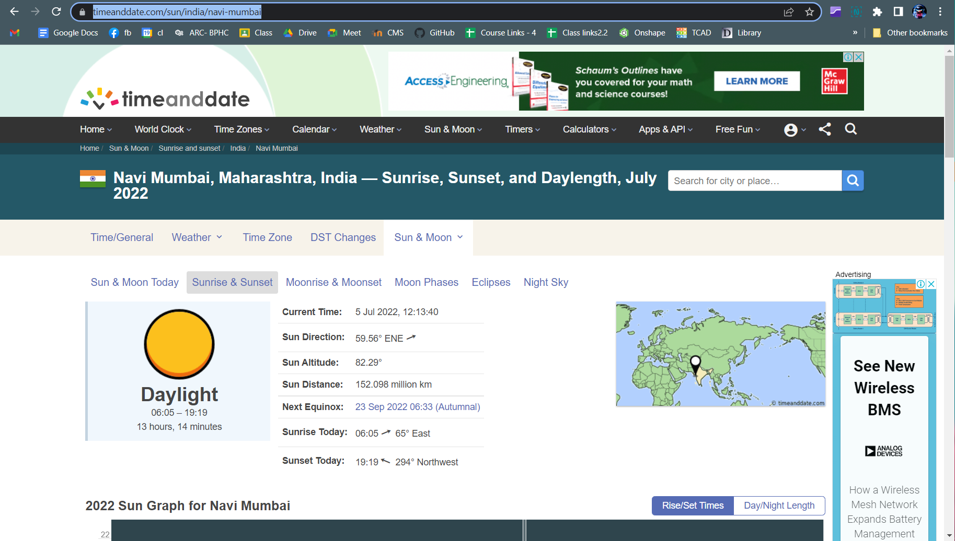

Relevant Data Marked for Usage:

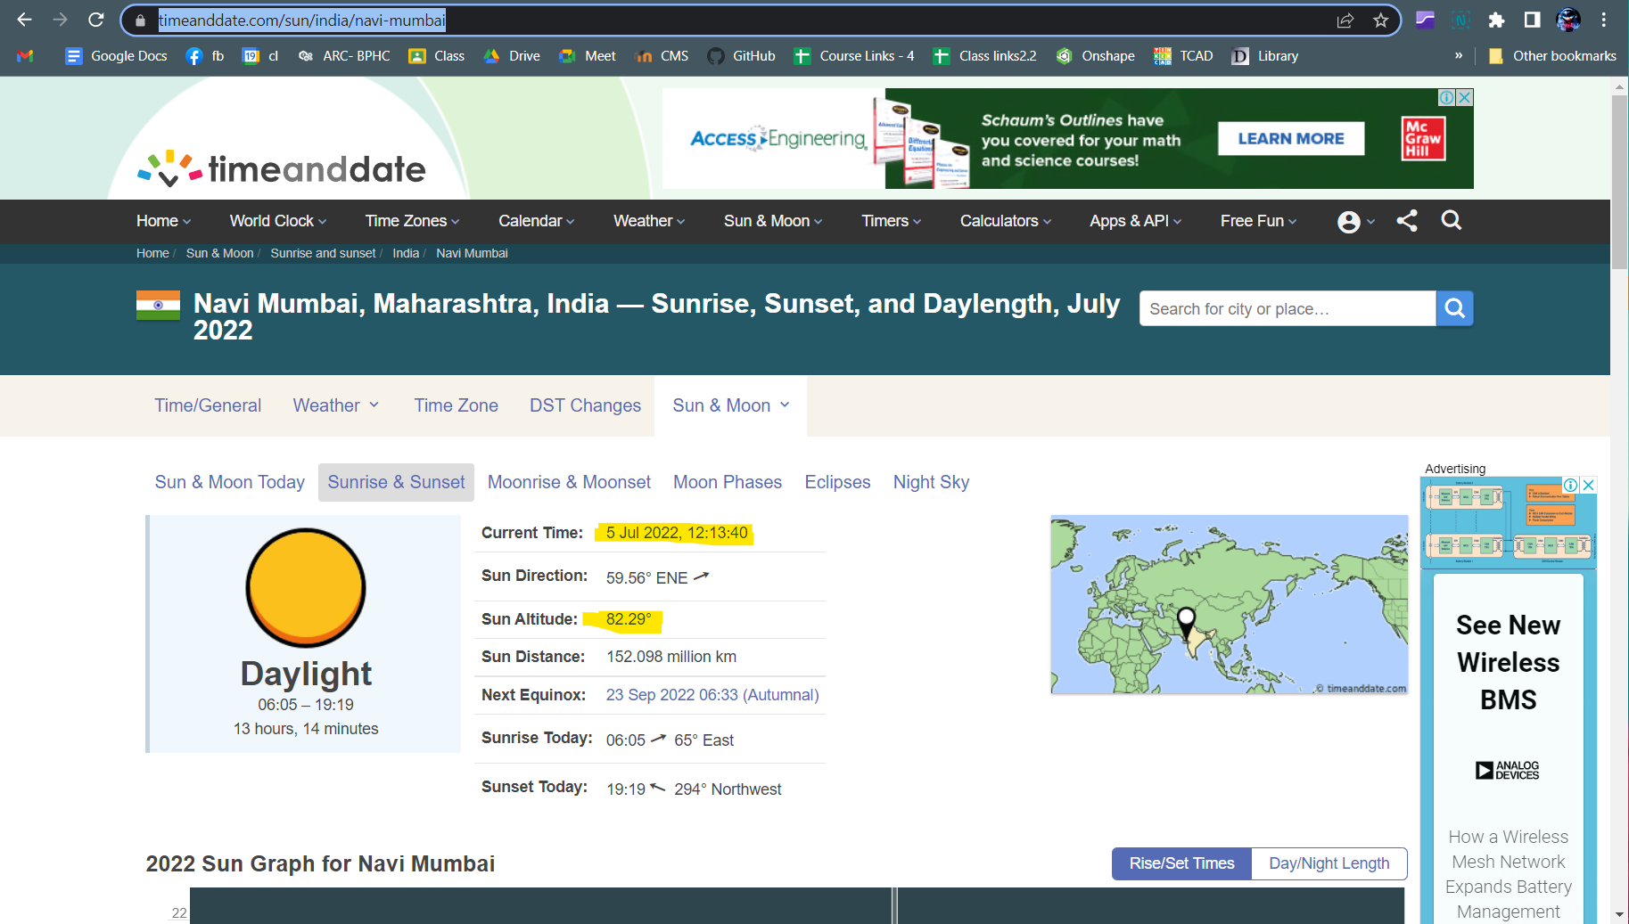

**Step2:Use the Inspect element and select the required data:**

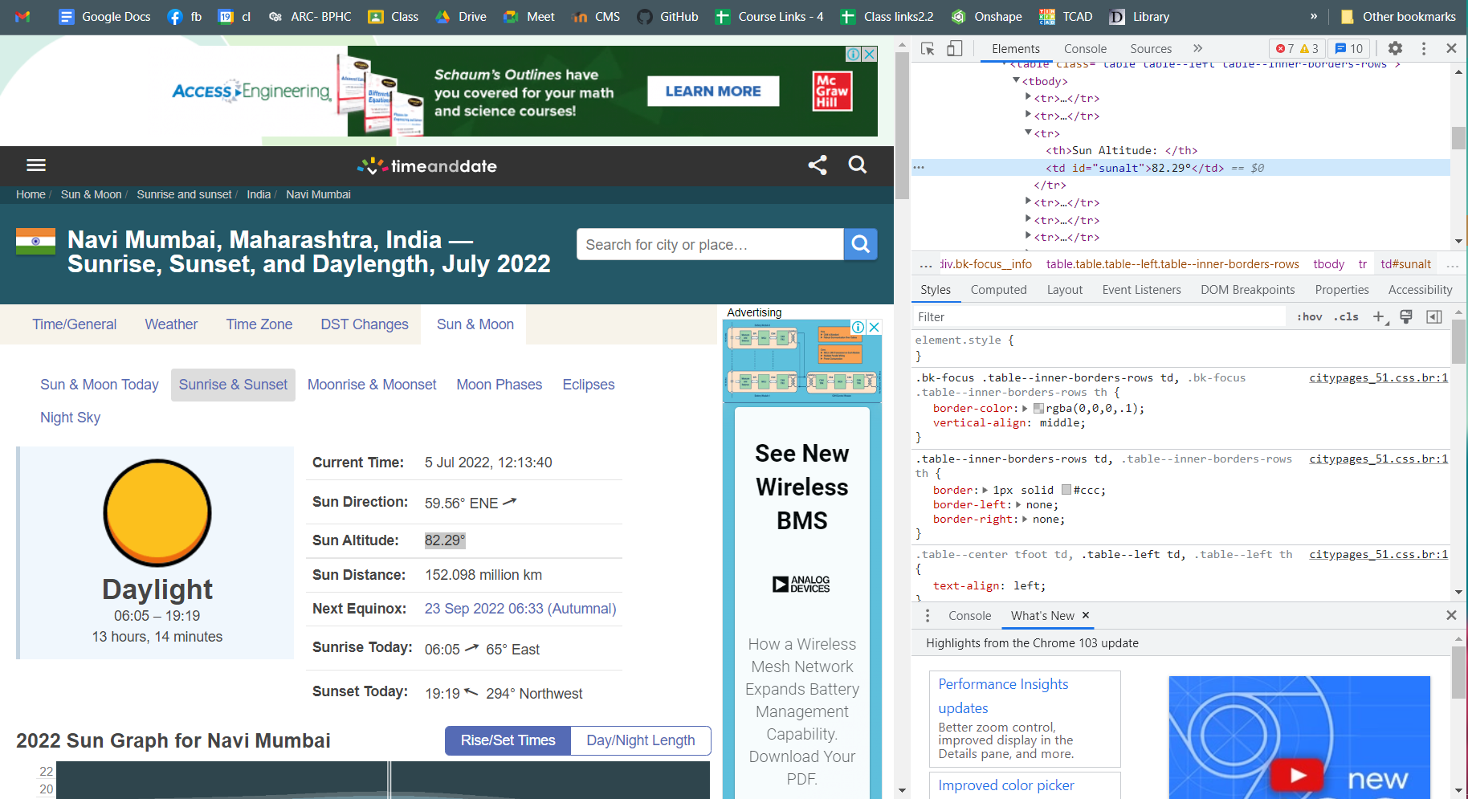

Select the highlighted part in the Elements Section and get the Xpath for the specific data.

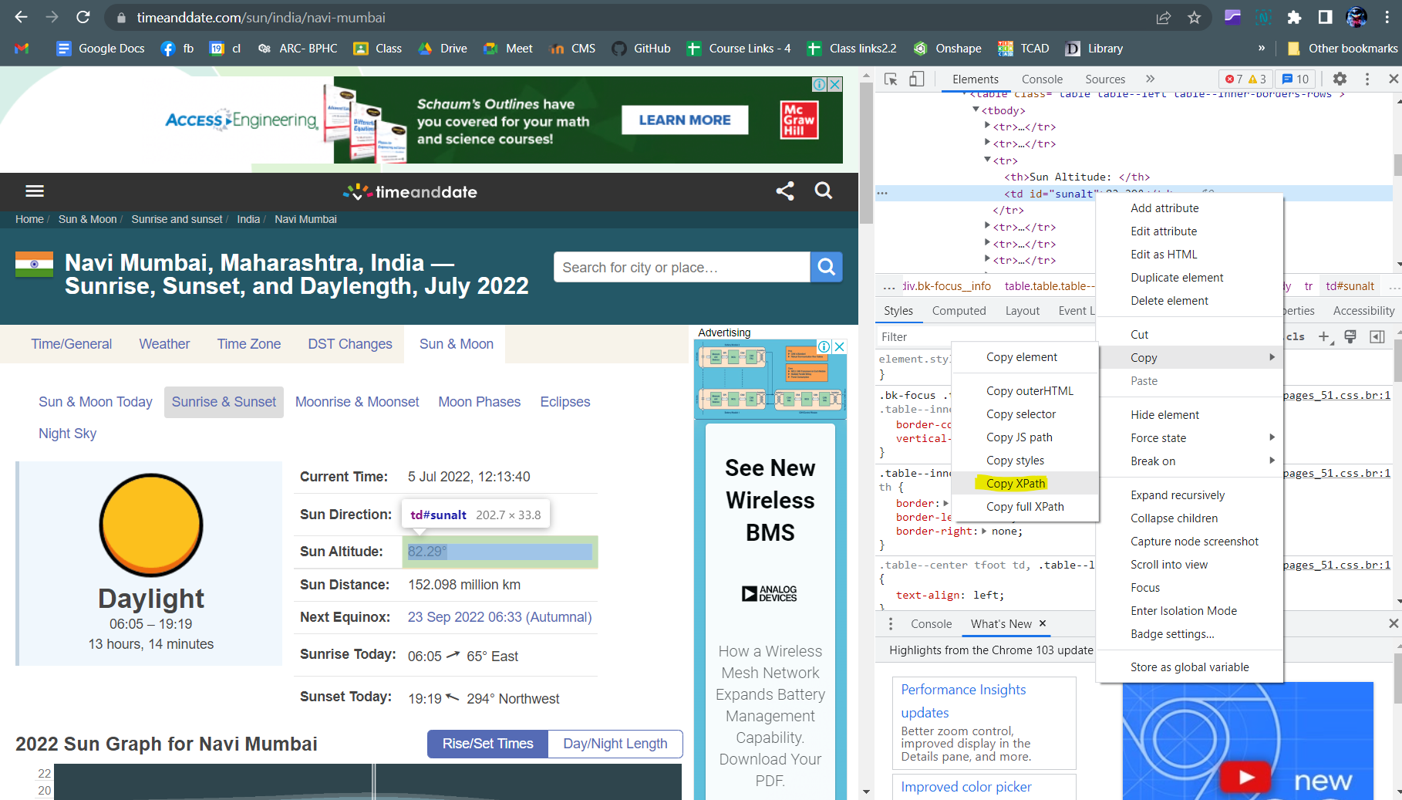

The copied Xpath would be something similar to this:

//*[@id="sunalt"]

**Step 3:**

**Use** [**Things Speak**](https://thingspeak.com/) **for API creation**

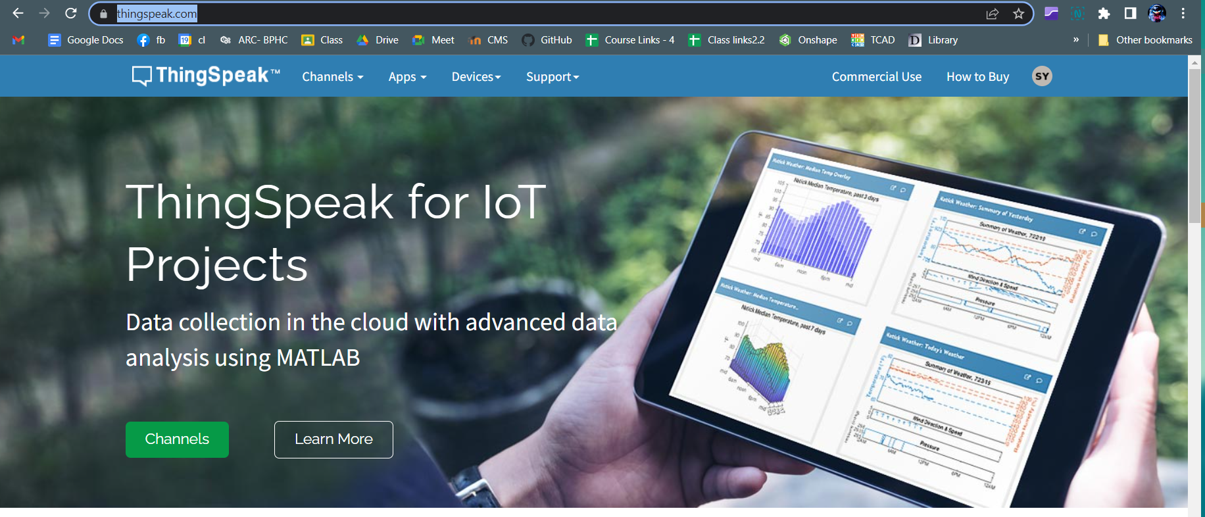

**Create a Mathworks account for using ThinkSpeak free of cost for making upto 10 APIs.**

**Step4:**

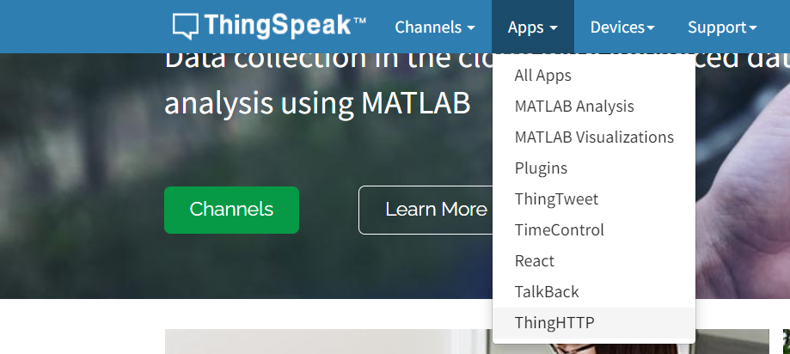

**Under Apps Section, Use ThingHTTP**

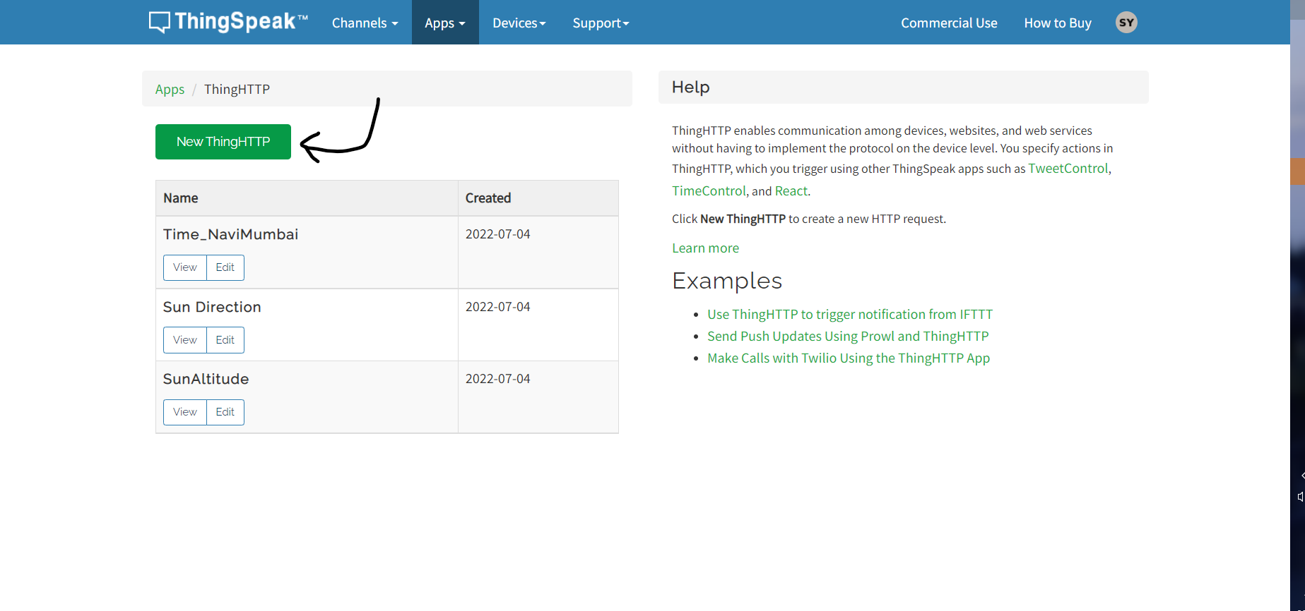

**Create a new ThingHTTP**

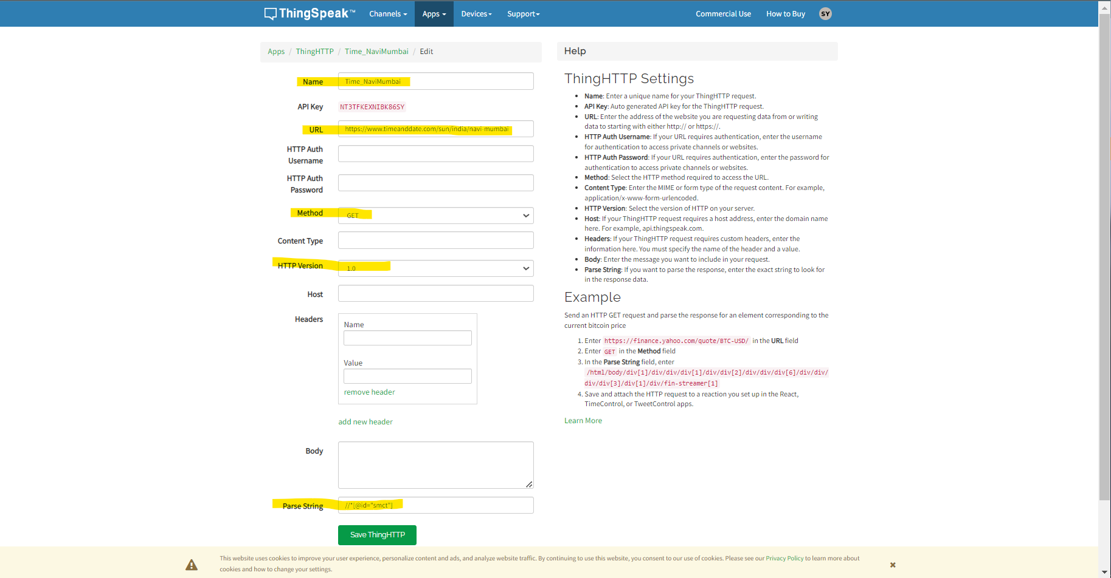

1. Give a name for the API

2. Copy and paste the URL of the Website used.

3. Ensure the method used is GET.

4. Ensure the HTTP version is 1.0

5. Paste the Xpath copied in the parse String.

6. Save the API.

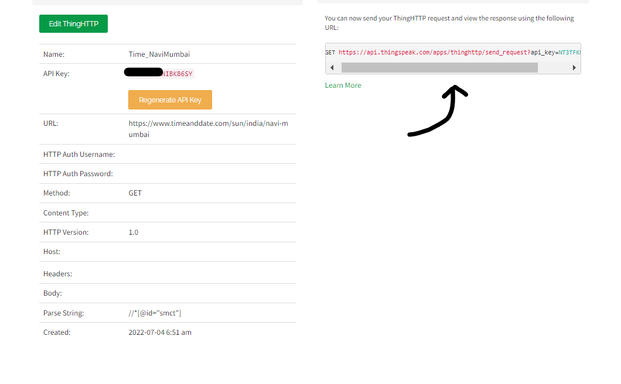

Now the API can be used through the given URL.

The next step would be to incorporate the URL in the code in the Arduino IDE.